

[MODULE: (2019) 6MMCS003C.1 Mobile User Experience](https://learning.westminster.ac.uk/webapps/blackboard/execute/courseMain?course_id=_75754_1)

**Style Guide**

Group Members

|  |  |  |
| --- | --- | --- |
| Name | IIT No | UOW No |
| Resindu Navoda | 2016352 | W1654203 |
| Suganthy Kangaiveniyan | 2017800 | W1699842 |
| Anojini Amaranathan | 2016437 | W1654577 |
| Weligama De Silva | 2016320 | W1654189 |

**Contents**

Introduction 3

Typography 4

Logotype 6

Colours 7

Icons 10

**Table of Figures**

Figure 1 Home page 3

Figure 2 Logo 6

Figure 3 Logo……………………………………………………………………………………...6

Figure 4:Contrast check for dark grey 8

Figure 5:Contrast Checke for Grey 9

Figure 6:Contrast check for orange 9

# 

# **Introduction**

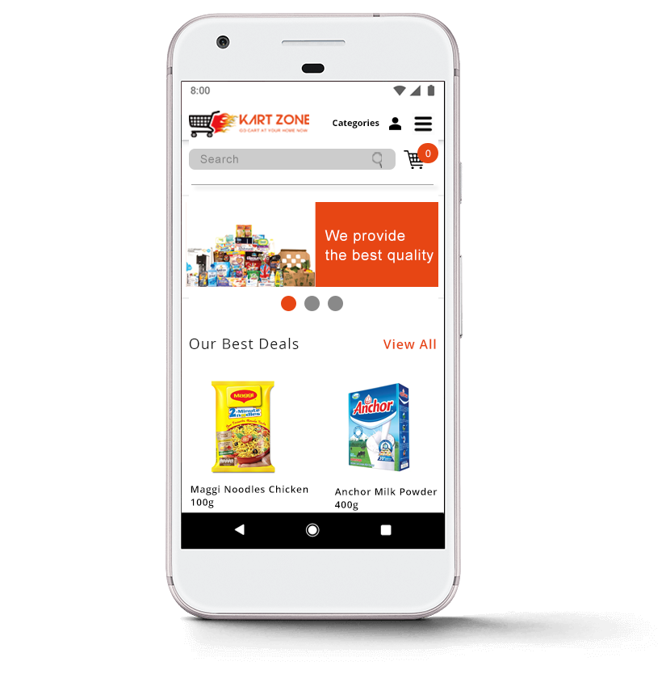

Kart Zone introduced another technology for launching the web app by an online supermarket in Sri Lanka.

Via this new web app customer can order the goods online and view ongoing Saver promotions as well as Cyber weekend promotions, contact us and send in any comment or suggestions they may have.

Figure Home page

# **Typography**

# **Typography Settings**

**1.     Headline: Open Sans Bold**

Font size mobile: 24px and up

Line height mobile: 120%

Font size tablet: 32px and up

Line height tablet: 90%

Text: upper case

Letterspacing: 0

Color: #000000

**2.     Sub headline: Open Sans Semibold**

Font size mobile: 9-16px

Font size tablet: 10-18px

Line height: 120%

Text: upper and lower case

Letterspacing: 0

Color: #5c5c5c

**3.     Bodycopy: Open Sans Regular**

Font size mobile: 9-16px

Font size tablet: 10-18px

Line height: 160%

Text: upper and lower case

Letterspacing: 0

Color: #383838

**4.     Labels: Open Sans Light**

Font size mobile: 9-16px

Font size tablet: 12-18px

Text: upper case

Line height tablet: 120%

Letterspacing: 0

Color: #7d7d7d

**Typography Justification**

Within the mobile application Open Sans font type is used to make the content within the application more readable and to look modern and classy.

Open Sans Bold is used for the headlines to emphasize the headline and Open sans semi bold is used for the sub headlines to emphasize the sub headlines. Open sans light is used for the labels as it expresses clean and neat mood.

For the bodycopy open sans light is used to make the content easy to read for any person. This font type is also readable for the visually impaired person.

**Header1**

**Header2**

Header3

Header4

**Logotype**

**Logo Description**

KART ZONE logo has been available to use as an Illustrator SVG format. This SVG image can be resized to any desired size for print or web without losing quality. For the KART ZONE Logo, we used Straus and Arial Typography to design.

KART ZONE mantra was “*GO CART AT YOUR HOME NOW*” this message represents, buy goods very easily and also the fire represents that customers will get their goods very speedy.

The name KART ZONE if typed should always appear in all capital letters. The only color to be for the logo should be the approved Orange and Black. Orange and White combinations are also used for the logo in categories interface to match with the orange color background . No other color combinations should be used when working with the Kart Zone Online Supermarket.

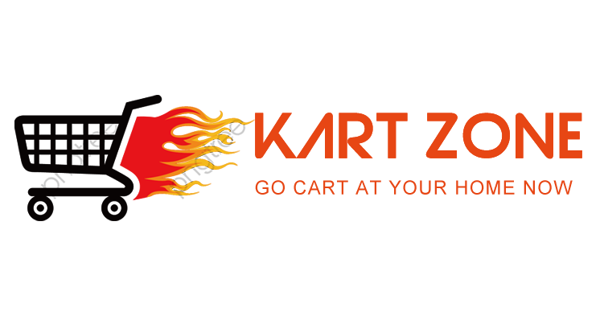

Figure Logo



Figure 3 Logo

# **Colors**

Black

#000000

R:0 G:0 B:0

Orange

#E74614

R:231 G:70 B:20

Light Grey

#6D6D6D

R:109 G:109 B:109

Grey

#565353

R:86 G:83 B:83

Dark Grey

#383838

R:56 G:56 B:56

White

#FFFFFF

R:255 G:255 B:255

Yellow

#1D3BD8

R:29 G:59 B:216

**Warning Messages**

Yellow

#FCF5DC

R:252 G:245 B:220

Red

#bf0000

R:191 G:0 B:0

**Success Messages**

Green

#00b050

R:0 G:176 B:80

Yellow

#FDE387

R:253 G:227 B:135

In the application Black color is used mostly on white background. This combination is used for headlines, body content etc. Dark grey on white background is also used for some of the body content. As shown in Figure 4 there is no accessibility issues when using dark grey on white background since it passes the minimum contrast ration of 4.5.

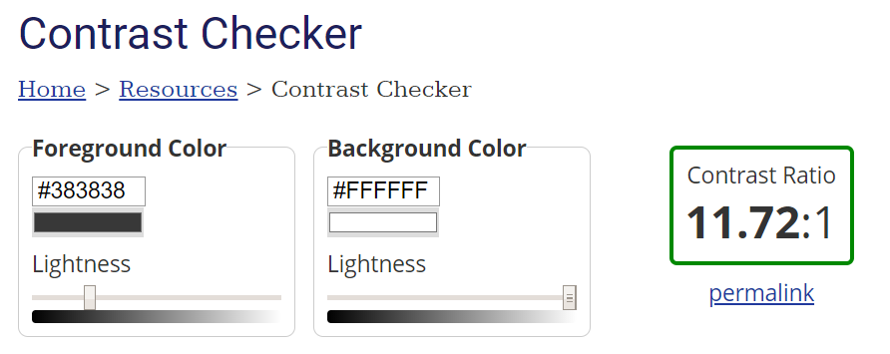

Figure 4

Grey used for sub headlines and light grey is used for labels. These two colors also used on white color background and there are no contrast issues as shown in Figure 5.

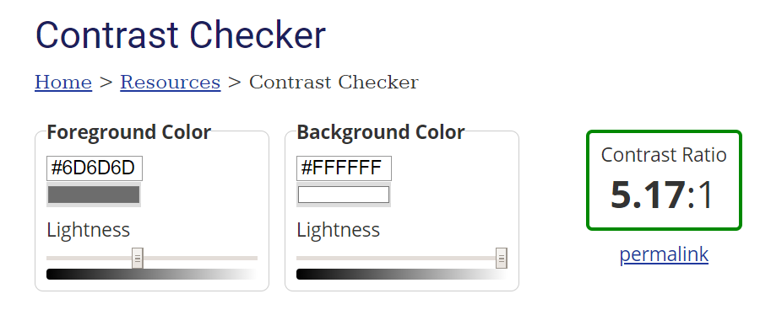

Figure 5

Black color on orange background is used for buttons. As shown in figure 6, this combination passes the contrast check with the ratio more than the minimum ratio. And also, orange on white background is also used in the application.

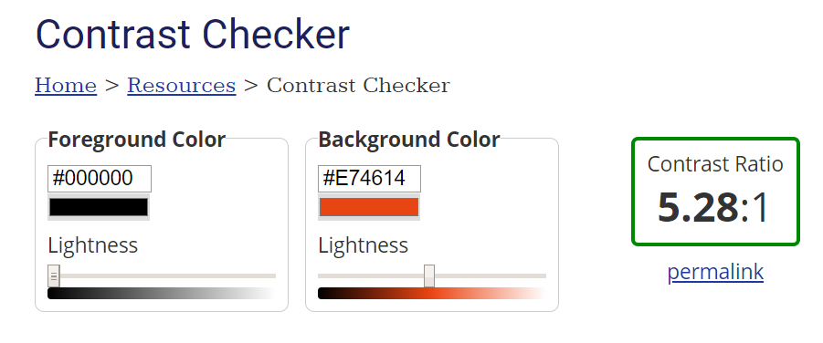

Figure 7

Yellow color is used in background to highlight some texts to drag more attention to those texts. Blue color text is used to specify offer amounts which helps to differentiate the offer price from normal price and highlight the offer price amount.

**Icons**









Left Arrow icon



QR code icon



Phone icon



Email icon



Successful icon

Location icon

Error icon

Account icon

Cart icon

Instagram icon

YouTube icon

Facebook icon

Search icon